**Game Brief**

**Influences of our Inspirations**

Taking the inspirations above into account, we had a clear plan of what we could aim for as our product. A speed run-friendly game seemed ideal, using a grading system for level completion, and allowing for competitive play using a scoreboard. Alongside this, gadget-based gameplay, quickly switching between gadgets to take Mario Kart-style shortcuts reliant on using the correct gadget at the correct time worked well with the idea. These take the form of various weapons, which can also be used to clear the way through enemies. The gameplay will mostly be that of a 3D platformer, with various enemies and challenges, but the player will be encouraged to complete the game as fast as possible, which is where the game's difficulty will come from. Newer players will be happy with the low challenge of moving through a level using a basic route, taking out enemies slowly, while skilled players can take various shortcuts, and attempt more difficult routes to lower their time and reach high scores.

**Theming and Visual Design**

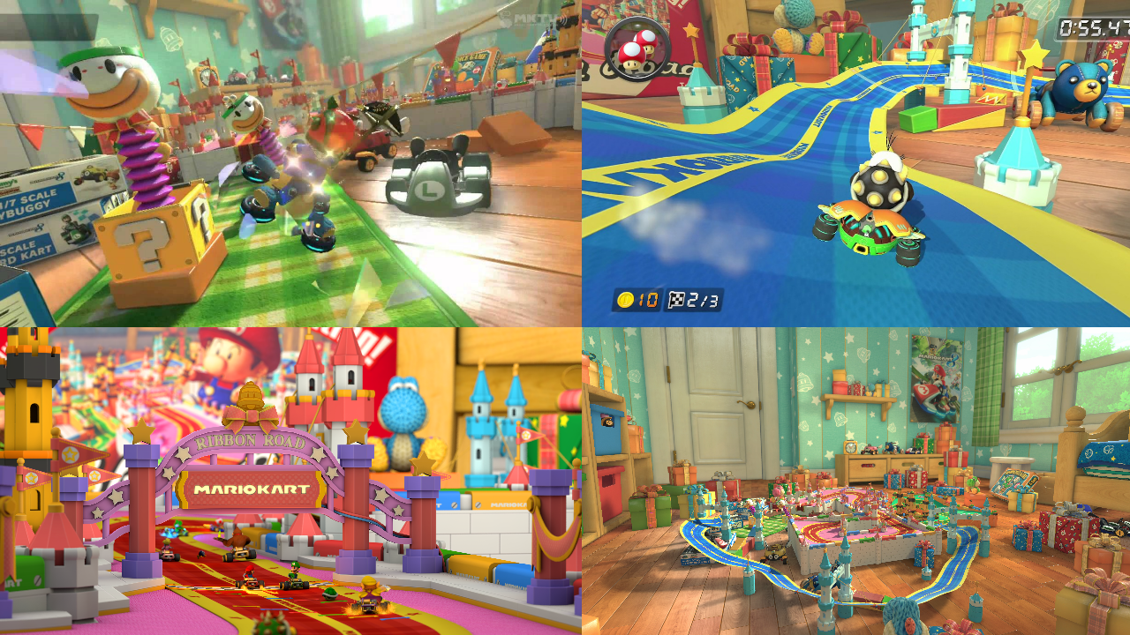

Figure 1 - Example screenshots from Mario Kart 8’s “Ribbon Road”

For theming, Ribbon Road from Mario Kart 8 intrigued the team, wanting to work with a shrunken theme using children's toys. This led to the decision to have the main character be a toy that comes to life, seeking an objective. The art style will be simple and polygonal, designed to look like basic toys a child might own. Levels will be designed with this theme in mind, using building blocks and toys to create environments.

**Our Concept**

This led to the development of “Sword and Board.” The game’s main character will be a child’s toy of a knight coming to life and going on an adventure. During this adventure the player will be fighting monsters made from other toys and jumping at speed on to platforms and between obstacles using the tight control scheme and movement upgrades within the game. The main objective will be to navigate platforming and combat challenges at speed to reach a shiny goal at the end of each level.